Automating E-Government Services with Artificial Intelligence

In this paper author describing concept to automate government services with Artificial Intelligence technology such as Deep Learning algorithm called Convolution Neural Networks (CNN). Government can introduce new schemes on internet and peoples can read news and notifications of such schemes and then peoples can write opinion about such schemes and this opinions can help government in taking better decisions. To detect public opinions about schemes automatically we need to have software like human brains which can easily understand the opinion which peoples are writing is in favour of positive or negative.

To build such automated opinion detection author is suggesting to build CNN model which can work like human brains. This CNN model can be generated for any services and we can make it to work like automated decision making without any human interactions. To suggest this technique author already describing concept to implement multiple models in which one model can detect or recognize human hand written digits and second model can detect sentiment from text sentences which can be given by human about government schemes. In our extension model we added another model which can detect sentiment from person face image. Person face expressions can describe sentiments better than words or sentences. So our extension work can predict sentiments from person face images.

This projects consists of following model

1. Generate Hand Written Digits Recognition Deep Learning Model: using this model we are building CNN based hand written model which take digit image as input and then predict the name of digit. CNN model can be generated by taking two types of images called train (train images contain all possible shapes of digits human can write in all possible ways) and test (Using test images train model will be tested whether its giving better prediction accuracy). Using all train images CNN will build the training model. While building model we will extract features from train images and then build a model. While testing also we will extract features from test image and then apply train model on that test image to classify it.
2. Generate Text & Image Based Sentiment Detection Deep Learning Model: using this module we will generate text and image based sentiment detection model. All possible positive and negative words will be used to generate text based sentiment model. All different types of facial expression images will be used to generate image based sentiment model. Whenever we input text or image then train model will be applied on that input to predict its sentiments.
3. Upload Test Image & Recognize Digit: By using this module we will upload text image and apply train model to recognize digit.
4. Write Your Opinion About Government Policies: using this module we will accept user’s opinion and then save that opinion inside application to detect sentiment from opinion.
5. View Peoples Sentiments From Opinions: using this module user can see all users opinion and their sentiments detected through CNN model.
6. Upload Your Face Expression Photo About Government Policies: using this module user will upload his image with facial expression which indicates whether user is satisfy with this scheme or not.
7. Detect Sentiments From Face Expression Photo: using this module different users can see the facial expression image and detected sentiment which is uploaded by past users.

CNN working procedure

To demonstrate how to build a convolutional neural network based image classifier, we shall build a 6 layer neural network that will identify and separate one image from other. This network that we shall build is a very small network that we can run on a CPU as well. Traditional neural networks that are very good at doing image classification have many more parameters and take a lot of time if trained on normal CPU. However, our objective is to show how to build a real-world convolutional neural network using TENSORFLOW.

Neural Networks are essentially mathematical models to solve an optimization problem. They are made of neurons, the basic computation unit of neural networks. A neuron takes an input (say x), do some computation on it (say: multiply it with a variable w and adds another variable b) to produce a value (say; z= wx + b). This value is passed to a non-linear function called activation function (f) to produce the final output (activation) of a neuron. There are many kinds of activation functions. One of the popular activation function is Sigmoid. The neuron which uses sigmoid function as an activation function will be called sigmoid neuron. Depending on the activation functions, neurons are named and there are many kinds of them like RELU, TanH.

If you stack neurons in a single line, it’s called a layer; which is the next building block of neural networks. See below image with layers

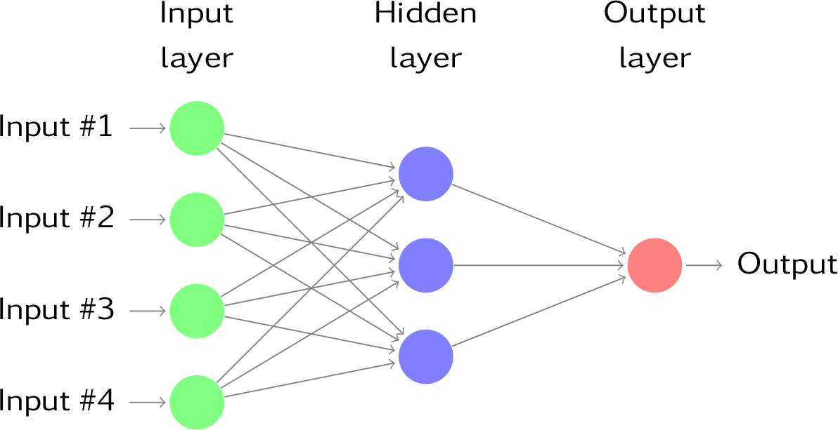

To predict image class multiple layers operate on each other to get best match layer and this process continues till no more improvement left.

Screen shots

All facial expression images you can upload from ‘expression_images_to_upload’ folder.

To run this project double click on ‘run.bat’ file to get below screen

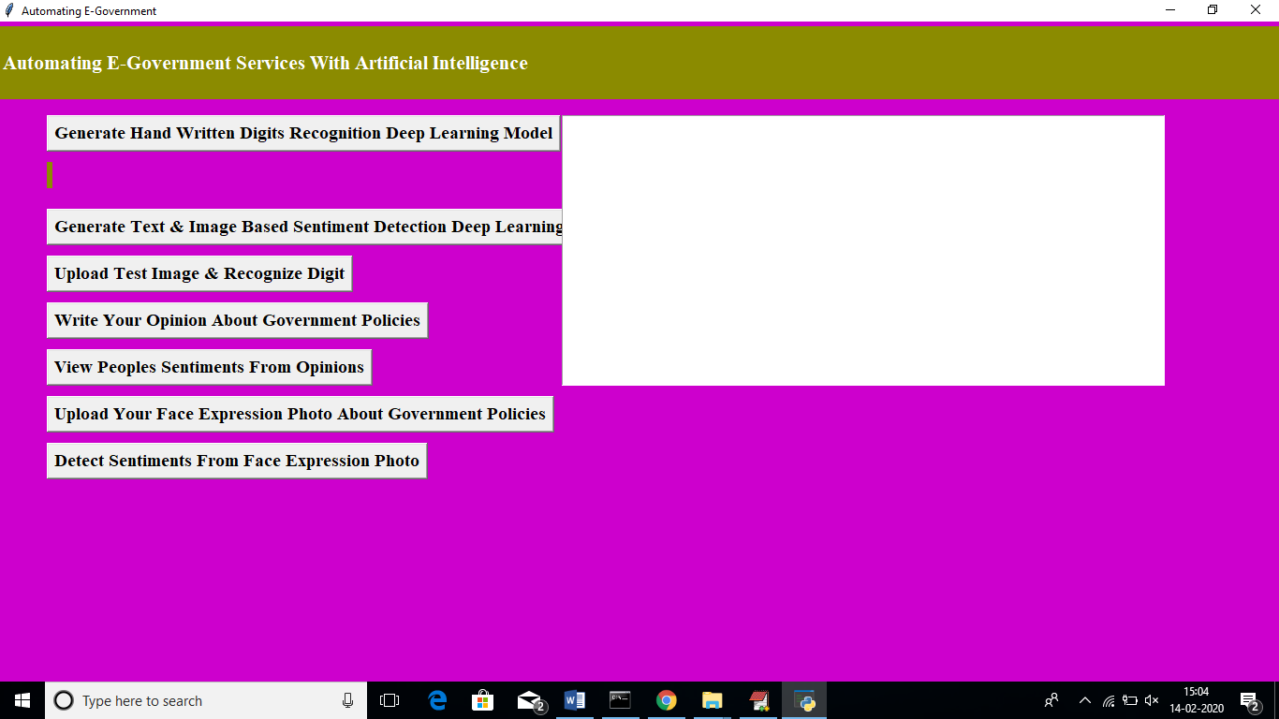

In above screen click on ‘Generate Hand Written Digits Recognition Deep Learning Model’ button to generate CNN digits recognition model

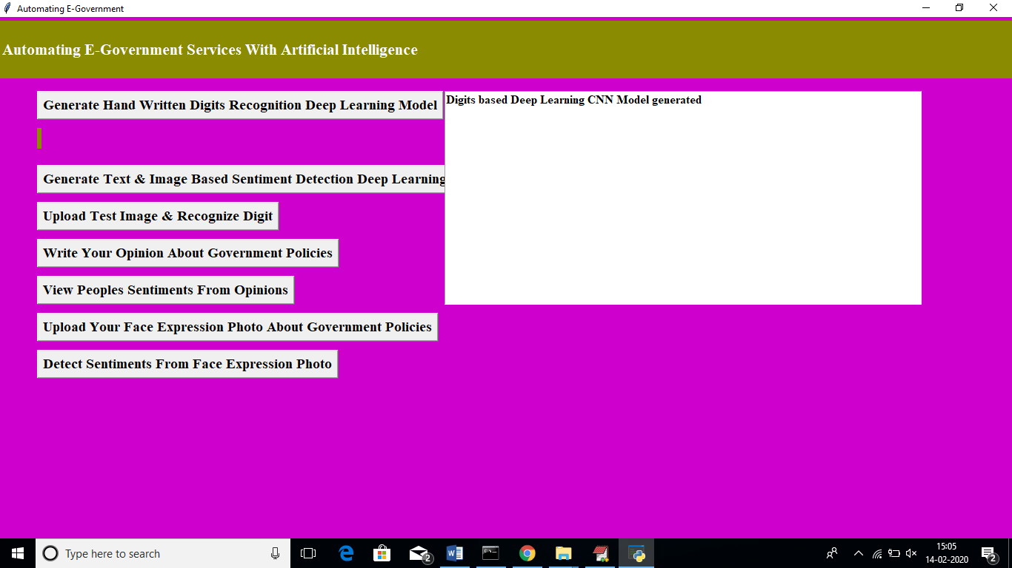

In above screen we can see digits model generated and CNN layer details you can see black console

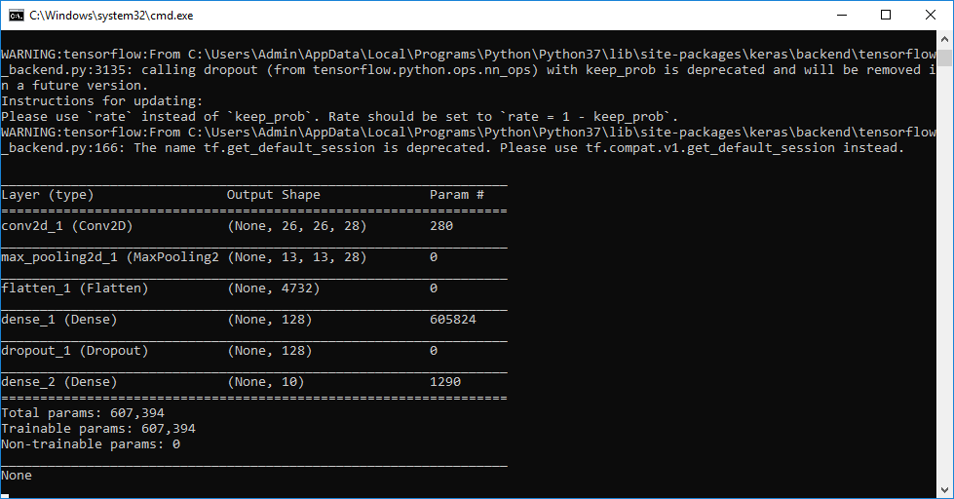

In above screen we can see Conv2d means convolution or CNN generate image features layer from different size as first layer generate with image size 26, 26 and second generated with 13 and 13 and goes on. Now click on ‘Generate Text & Image Based Sentiment Detection Deep Learning Model’ button to generate CNN for text and image based sentiment detection model.

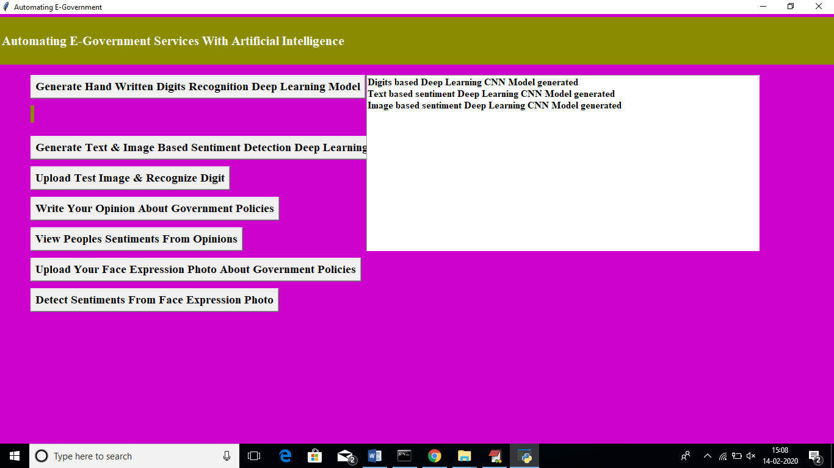

In above screen we can see text and image based CNN model generated. See black screen for more details

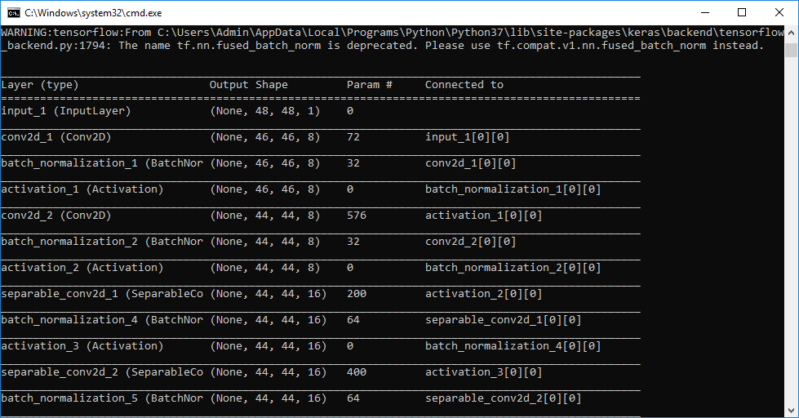

Now click on ‘Upload Test Image & Recognize Digit’ button to upload digit images and to get name of that digit. All digit images saved inside testImages folder

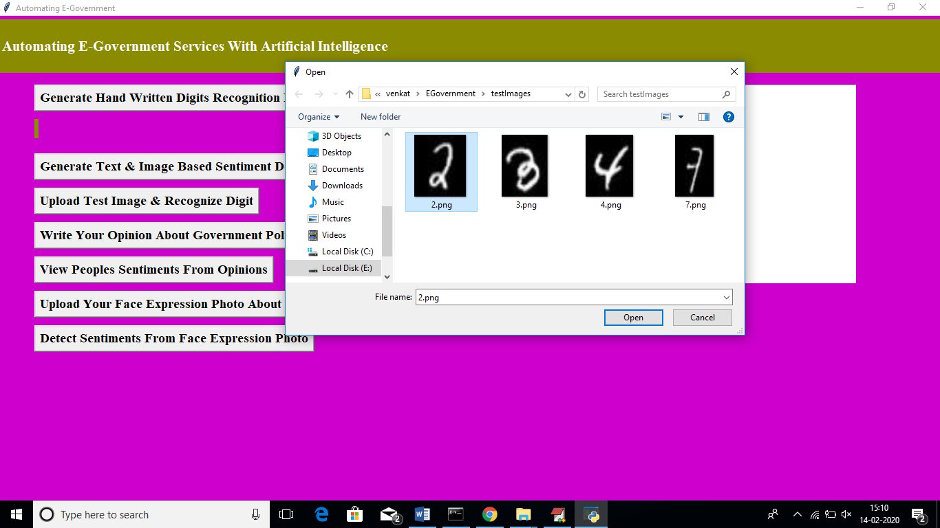

In above screen I am uploading image which contain digit 2 and below is the output of detection

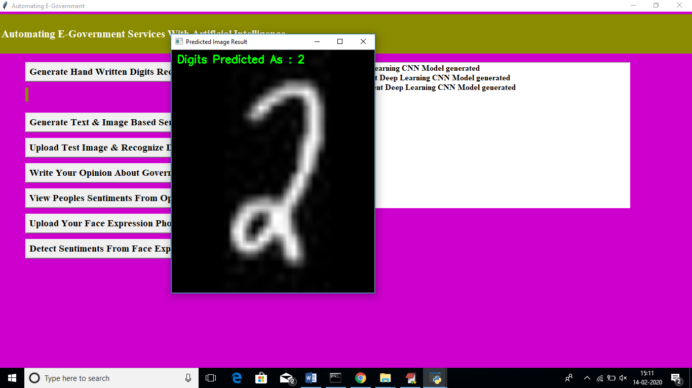

In above screen we can see Digits Predicted as: 2. Now click on ‘Write Your Opinion About Government Policies’ button to write some comments on government policy

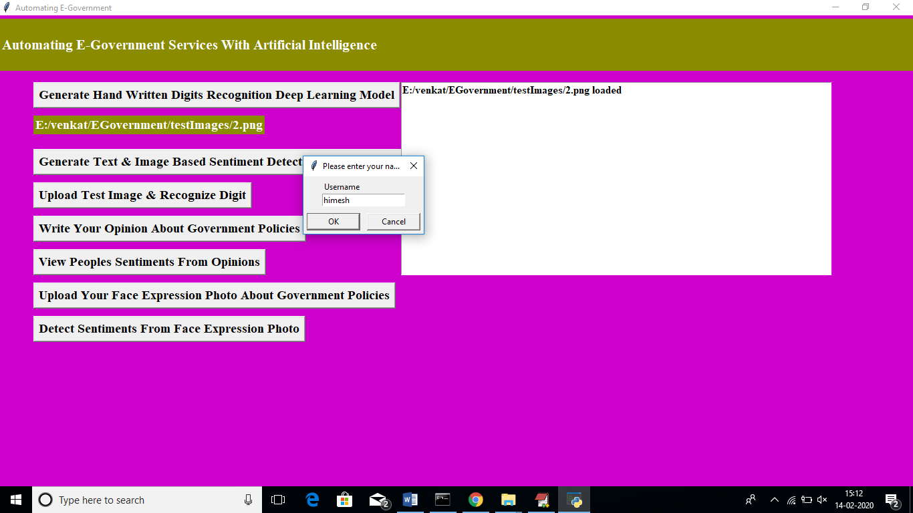

In above screen before writing opinions we need to write username after writing username click ok button to get below screen

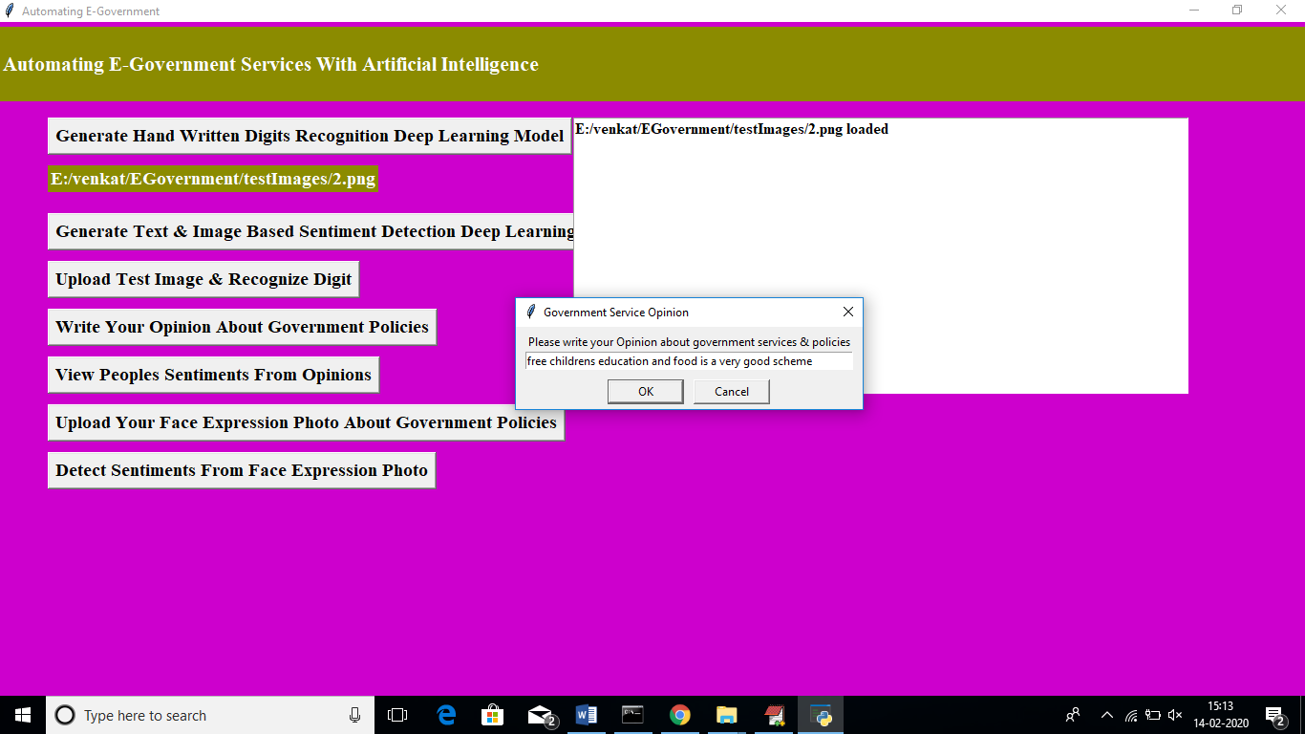

In above screen I wrote some comment on some scheme and application detect sentiment from it as positive or negative. Now click on ‘View Peoples Sentiments From Opinions’ button to view all opinions from past users.

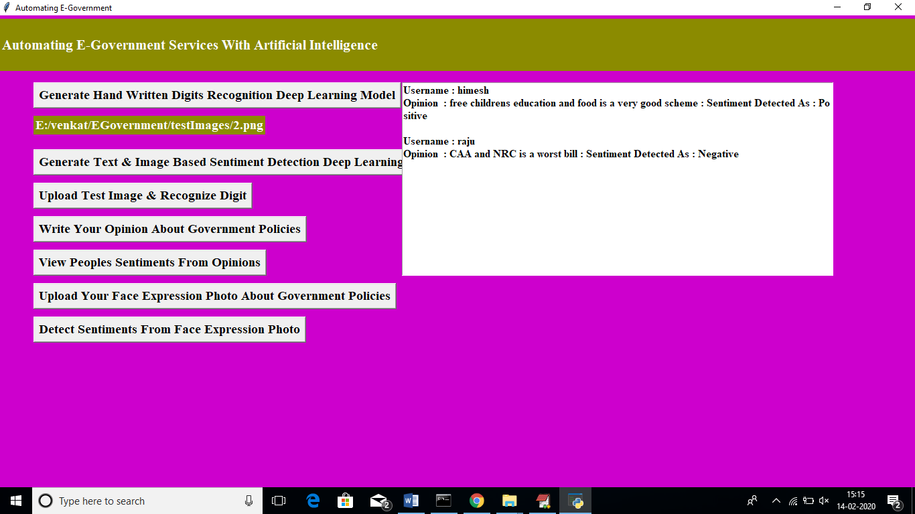

In above screen text area we can see opinions from all users and in first opinion we got sentiment detected as positive which means user is satisfy with that scheme and for second opinion we got sentiment as negative which means user not happy. Similarly user can upload their image with facial expression which describe whether user is happy or angry

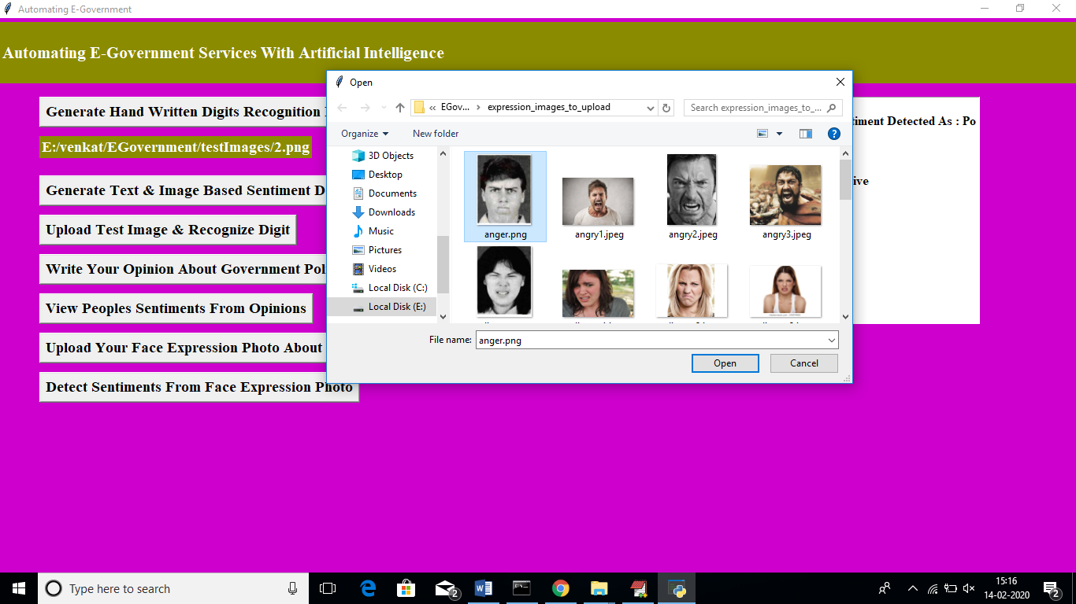

In above screen I am uploading one anger face image and then application ask to write username and referring scheme name. similarly any number of users can upload their images. Now click on ‘Detect Sentiments From Face Expression Photo’ button to get all images and its detected sentiments



In above screen we can see all images with facial expression are identified with their sentiments. In dialog box also we can see sentiment result.

Similarly you can enter any number of comments or facial images to detect their sentiments